AI-Powered Basketball Analytics: YOLOv11-Based Player, Ball, and Hoop Detection with Pose Estimation, AI Commentary, and Shot Prediction

^{1st} Dr. Jitendra musale, ^{2nd} Abhishek Khomane, ^{3rd} Abhishek Adsul ^{4th} Rahul Dhope, ^{5th} Kundlik Gavhane,
Computer department of Anantrao pawar college of engineering and research,parvati,pune.
Savitribai Phule Pune university
pune.
jitendra.musale@abmspcoerpune.org
Abstract-In this research, we present an AI-powered basketball analysis system that integrates YOLOv11-based player detection, basketball tracking, and hoop recognition, along with pose estimation for advanced movement analysis. Our system accurately identifies and tracks ball possession, dribbling patterns, and shot attempts, enabling real-time performance evaluation. To enhance interactivity, we incorporate an AI-driven commentary feature that provides real-time audio feedback when specific in-game events occur, such as double dribbles or successful shots. Additionally, our system includes a basketball shot prediction model, utilizing polynomial regression to analyze ball trajectories and predict shot success probabilities. This feature assists players in refining their shooting techniques and optimizing their performance. The entire framework is deployed within a Tkinter-based desktop application, offering a user-friendly interface for coaches, analysts, and players to monitor game activities and receive actionable insights. Our approach combines computer vision, deep learning, and real-time analytics to deliver an immersive and data-driven basketball analysis experience. By automating key aspects of player tracking, rule enforcement, and performance evaluation, this system has the potential to revolutionize basketball training, coaching strategies, and referee decision-making. The integration of AI and machine learning in sports analytics paves the way for smarter gameplay analysis, reduced human error, and enhanced player development.Keywords-Computer Vision, Player Detection, Player Tracking Basketball Videos, Object Detection, YOLO Algorithm.

Keywords: YOLOv11, Basketball Analytics, Player Detection, Pose Estimation, Ball Tracking, Hoop Detection, AI Commentary, Shot Prediction, Computer Vision, Deep Learning, Sports Technology, Real-Time Analysis, Tkinter-based Application, Game Refereeing, Performance Optimization.
- Introduction
Basketball is a fast-paced sport that demands precision, strategy, and real-time decision-making from players, coaches, and referees. Traditional methods of game analysis rely heavily on manual observation and subjective judgment, which can lead to inefficiencies and errors in performance evaluation and rule enforcement. With advancements in computer vision and artificial intelligence (AI), automated solutions can now provide real-time insights, accurate player tracking, and intelligent rule monitoring to enhance both training and officiating in the sport.

This research introduces an AI-powered basketball analysis system that integrates YOLOv11-based player detection, basketball and hoop tracking, and pose estimation to analyze in-game actions with high precision. The system is designed to detect key events such as ball possession, dribbling patterns, and shot attempts, enabling real-time tracking of player movements and game dynamics. Additionally, the system includes an AI-driven commentary feature, which provides instant audio feedback on critical game violations such as double dribbles, making it a valuable tool for both training and referee decision-making.

Another core component of the system is shot prediction using polynomial regression, which analyzes the trajectory of the basketball to determine the likelihood of a successful shot. This feature helps players refine their shooting techniques by providing real-time feedback on shot accuracy and arc adjustments. Implemented within a Tkinter-based desktop application, the system provides a user-friendly interface for coaches, analysts, and players to visualize game analytics and improve decision-making.

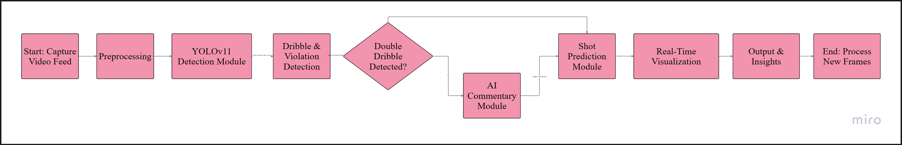
Figure 1.1: System Architecture of YOLOv11-Based AI Basketball Analytics

By combining computer vision, deep learning, and real-time analytics, this research aims to revolutionize basketball training, coaching strategies, and referee decision-making. The proposed system not only enhances player performance but also automates game rule enforcement, reducing human error and improving overall game analysis efficiency. The integration of AI-powered sports technology paves the way for smarter, data-driven insights, ultimately transforming the way basketball is played, coached, and officiated.

  - Significance of Technology: The integration of artificial intelligence and computer vision in sports analytics has revolutionized the way basketball is played, coached, and officiated. Traditional methods of player tracking, rule enforcement, and performance evaluation rely on manual observation, which is often subjective and prone to errors. With advancements in deep learning, models like YOLOv11 provide real-time detection of basketball players, ball movements, and hoop positioning with high accuracy. The incorporation of pose estimation further enhances the system's capability to analyze player actions, such as dribbling, shooting, and defending, offering valuable insights for performance improvement. By automating these processes, AI enables teams and analysts to make data-driven decisions, improving player performance, strategy formulation, and game integrity. A key innovation in this system is the AI-powered commentary feature, which provides real-time audio feedback on in-game events, such as double dribble violations.

This feature enhances referee decision-making by reducing human error and improving the overall viewing experience for players, coaches, and audiences. Traditional refereeing systems rely heavily on human perception, which can sometimes lead to controversial or missed calls. By integrating an automated commentary system, this technology not only assists in officiating but also enhances the spectator experience, making the game more engaging and informative. The commentary is triggered through a detection pipeline that continuously monitors gameplay, ensuring that violations and key game moments are accurately identified and reported in real-time. Another critical component of the system is the shot prediction module, which utilizes polynomial regression to analyze ball trajectory and shooting patterns. This allows the system to estimate the likelihood of a successful shot based on historical data and real-time tracking.

Players can receive instant feedback on their shooting form, helping them refine techniques and optimize shot selection. Coaches can also leverage this feature to identify patterns in a player’s shooting performance, providing targeted training and corrective measures to enhance accuracy and efficiency. Beyond individual player performance, AI-powered basketball analytics play a crucial role in team strategy and opponent analysis. By tracking movement patterns and analyzing game dynamics, the system can provide valuable insights into offensive and defensive strategies.

This allows coaches to make data-driven adjustments during games, such as modifying defensive schemes or optimizing player rotations. The ability to analyze an opponent’s tactics in real-time further gives teams a competitive advantage by enabling quick and effective counter-strategies. To ensure accessibility and ease of use, the system is implemented with a Tkinter-based graphical user interface, which provides real-time visualizations of player movements, shot success probabilities, and AI-generated commentary. The interactive nature of the interface allows analysts to customize the system according to their requirements, such as filtering specific player movements, adjusting sensitivity for event detection, and generating detailed post-game reports. In addition to performance tracking and strategy analysis, this technology enhances sports broadcasting and fan engagement.

The integration of AI-powered insights into live broadcasts enables commentators to provide deeper statistical analysis, offering audiences a more immersive and informed viewing experience. Augmented reality overlays can further enrich the experience by displaying live statistics, player heatmaps, and predicted shot success rates during games. By leveraging AI and computer vision, this technology bridges the gap between traditional coaching methods and modern performance analytics, paving the way for smarter training systems, more efficient referee decisions, and enhanced gameplay strategies. The implementation of real-time analytics, automated rule enforcement, and AI-generated insights has the potential to redefine the future of basketball coaching, training, and officiating, making the game more data-driven, precise, and interactive.
- Literature Survey
J. Yang et al. [1] proposed an advanced rainy-day object detection framework that integrates YOLOv11 with Fast Fourier Transform (FFT) and Model Fusion (MF) to improve detection accuracy under adverse weather conditions. Their method addresses challenges such as rain-induced distortions, low visibility, and environmental reflections, which often degrade the performance of traditional object detection models. By incorporating FFT, the system effectively suppresses noise and enhances feature extraction, while MF combines multiple deep learning architectures to improve object recognition in low-contrast environments. This approach significantly enhances YOLOv11’s ability to detect objects in real-world scenarios, including autonomous driving, surveillance, and meteorological monitoring. Their research underscores the importance of integrating deep learning with signal processing techniques to build more reliable and weather-resilient object detection systems. (al, 2024)

Z. Su [2] introduced a basketball action recognition system based on an improved OpenPose algorithm to enhance computer-assisted learning in sports education. The study addresses limitations in traditional video-based tutorials, such as lack of standardization and ineffective posture assessment, by employing pose estimation techniques to analyze and compare player movements with standardized actions. The system reconstructs human skeletal structures, calculates joint angles, and provides real-time feedback for posture correction, making it a valuable tool for improving basketball techniques. Experimental results demonstrate the effectiveness of this approach in refining player movements and ensuring better training outcomes. The integration of machine learning algorithms further enhances the system’s adaptability, allowing for personalized learning experiences and continuous model improvement. This research highlights the growing significance of AI-driven sports training tools and suggests broader applications beyond basketball, reinforcing its role in improving skill acquisition and performance evaluation. (Su, 2024)

S. Karungaru et al. [3] proposed a basketball player identification and tracking system using a single fixed camera, leveraging computer vision techniques for real-time analysis. The study integrates consecutive intersection over union (IOU)-based tracking with K-Means clustering to identify teams based on uniform colors. A retrained YOLOv7 model is employed to detect players, referees, the basketball, and field markers, ensuring precise object recognition. To address challenges related to occlusion, the system incorporates a Kalman filter, improving tracking consistency and reliability. The research highlights the potential of data-driven sports analytics for tactical development, opponent analysis, and in-game decision-making. By providing an affordable and effective solution for both amateur and professional teams, this study reinforces the growing role of AI and machine learning in basketball performance evaluation and strategic planning. (al., 2023)

Z. Xian-jiang et al. [4] conducted a study on the key factors influencing success in competitive basketball, emphasizing the importance of strategic and performance-based elements in achieving victories. The research highlights that winning is both the starting and ending objective of the sport, necessitating a systematic approach to outperform opponents. Using statistical analysis and reliability theory, the study identifies critical factors such as player skills, team coordination, tactical execution, and decision-making under pressure. The findings provide insights into how teams can refine training methodologies, optimize gameplay strategies, and enhance overall performance to maximize their chances of success. This research serves as a foundational reference for basketball analysts and coaches seeking data-driven methods to improve team competitiveness and achieve consistent victories. (al. Z. X.-j., 2008)
S. Takagi et al. [5] proposed a mixed reality (MR)-based learning support system for analyzing gaze trends in basketball using HoloLens2 and eye-tracking technology. The study focuses on enhancing players' situational awareness and decision-making by visualizing their gaze patterns during gameplay. By leveraging MR, the system provides real-time feedback on where players focus their attention, helping coaches and analysts understand visual attention distribution, reaction time, and decision-making efficiency. The integration of target tracking and virtual overlays allows players to refine their court vision, improving their ability to anticipate movements and execute plays effectively. The research highlights the potential of MR environments in sports training and cognitive skill enhancement, making it a valuable tool for both professional and amateur players. (al. S. T., 2025)
S. Fang et al. [6] introduced a deep learning-based approach for extracting technical features from basketball videos to enhance motion tracking and video analysis. The study leverages convolutional neural networks (CNNs) and recurrent neural networks (RNNs) to encode and decode player movements, enabling a more detailed understanding of gameplay dynamics. By integrating human-computer interaction techniques, the system generates deeply engineered features that improve real-time basketball video interpretation. The proposed method enhances motion tracking, player behavior recognition, and tactical analysis, making it a valuable tool for both sports analysts and automated coaching systems. The research underscores the importance of advanced feature extraction techniques in improving real-time basketball analysis, visualization, and training methodologies. (al. S. F., 2025)
S. Lee et al. [7] proposed a multi-agent deep reinforcement learning (MARL) framework for online team sports games, focusing on human strategy learning to enhance AI decision-making in dynamic gameplay environments. The study leverages deep reinforcement learning (DRL) algorithms to train AI agents capable of replicating real-world strategic behaviors observed in human players. By integrating multi-agent collaboration and real-time decision processing, the system effectively adapts to changing game conditions, opponent strategies, and team formations. The proposed approach enhances the realism and intelligence of AI-driven sports simulations, making it applicable to automated coaching, strategic analysis, and AI-driven gameplay training. This research highlights the potential of AI-based learning models in refining tactical decision-making for team sports. (al. S. L., 2025)
L. Jiang et al. [8] introduced a transformer-based multi-player tracking and skill recognition framework for volleyball analytics, leveraging deep learning for enhanced performance evaluation. The study employs transformer networks to extract detailed features from player movements, improving the accuracy of multi-player tracking and skill classification. By integrating multi-modal data processing, the system effectively analyzes player positioning, movement patterns, and tactical execution in real-time. The research demonstrates the advantages of transformer-based models over traditional tracking methods, particularly in handling occlusions, rapid player movements, and complex team interactions. The proposed framework has significant applications in automated sports analytics, performance assessment, and AI-driven coaching strategies, offering valuable insights for both professional and amateur volleyball players. (al. L. J., 2025)
Y. Ma et al. [9] proposed an efficient real-time sports action pose estimation framework using EfficientPose and Temporal Graph Convolution Networks (T-GCN) to enhance motion tracking accuracy in dynamic sports environments. The study focuses on improving 3D pose estimation by leveraging lightweight deep learning models that ensure fast and accurate detection of player movements while maintaining computational efficiency. The integration of T-GCN enables temporal modeling, allowing the system to track continuous player actions and provide real-time performance feedback. The proposed method demonstrates superior accuracy and speed compared to conventional pose estimation techniques, making it suitable for real-time sports analytics, player performance evaluation, and AI-driven training systems. This research highlights the importance of computationally efficient deep learning models in enhancing sports action recognition and pose estimation. (al. Y. M., 2025)

S. Wang and S. Zhou [10] introduced PlayerNetVis, a visual analytics system designed for evaluating NBA player performance based on network topology analysis. The study applies graph-based models to represent player interactions, analyzing passing efficiency, tactical roles, and overall team contribution. By integrating statistical analysis and visual analytics techniques, the system provides a comprehensive evaluation of player abilities and strategic positioning within a game. The research highlights the importance of network-based performance assessment, enabling coaches and analysts to identify key playmakers, ball distribution patterns, and tactical strengths or weaknesses. PlayerNetVis offers an intuitive interface for data-driven decision-making in team management, scouting, and game strategy optimization, reinforcing the role of advanced analytics in professional basketball evaluation. (Zhou, 2020)

R. Qasrawi et al. [11] proposed an automatic analytics model for learning skill analysis using game player data and robotic process automation (RPA) in a serious game for education. The study focuses on game analytics and automation, leveraging data-driven models to evaluate player performance, track skill development, and provide personalized learning feedback. By integrating robotic process automation, the system automates data collection, processing, and analysis, ensuring efficient and scalable learning assessments. The research highlights the significance of AI-driven analytics in educational gaming, demonstrating how game player data can be utilized to enhance skill acquisition, optimize training methodologies, and improve overall engagement. The proposed model offers valuable applications in serious gaming, adaptive learning environments, and AI-powered educational tools. (al. R. Q., 2020)

A. J. Park and H. H. Tsang [12] introduced Dynalink, a visual analytics system designed to detect key players in criminal networks using social network analysis (SNA). The study focuses on identifying central figures within co-offending networks by analyzing relationships, interactions, and influence patterns among individuals involved in criminal activities. By leveraging data visualization and network topology methods, Dynalink highlights key connections and behavioral patterns, allowing law enforcement agencies to track and disrupt criminal organizations more effectively. The research demonstrates the applicability of network analysis beyond criminology, suggesting potential uses in team sports analytics, organizational behavior studies, and intelligence operations where identifying influential individuals is crucial for strategic decision-making. (Tsang, 2013)

V. C. Pantzalis and C. Tjortjis [13] presented a sports analytics framework for football league table and player performance prediction using machine learning (ML) and data mining techniques. The study explores classification and regression models to analyze team performance, player statistics, and match outcomes, aiming to enhance the reliability of predictive models in sports analytics. By leveraging historical data, the system identifies key performance indicators (KPIs) that influence league standings and individual player success. The research highlights the effectiveness of ML-driven predictive analytics in improving team management, scouting, and game strategy formulation, demonstrating the broader applicability of data-driven decision-making in professional sports. (Tjortjis, 2020)
- Research Methodology
- Literature Review:
The research methodology for this study is structured to ensure accurate detection, tracking, and analysis of basketball gameplay using computer vision and deep learning techniques. The proposed system integrates YOLOv11 for object detection, pose estimation for movement analysis, and polynomial regression for shot prediction, along with an AI-driven commentary system to enhance user experience. The methodology consists of several key stages, including data acquisition, preprocessing, model training, real-time inference, and system integration into a Tkinter-based GUI application.

- Dataset collection and selection:
To develop a robust and efficient AI model, high-quality basketball game footage was collected from publicly available datasets, real-world matches, and recorded training sessions. These videos contain diverse scenarios, including varied camera angles, lighting conditions, player movements, and ball trajectories, ensuring that the model generalizes well across different gameplay situations. Each frame is extracted and annotated with bounding boxes for players, basketball, and hoop positions, facilitating supervised learning for object detection models.

- Preprocessing:
Before training, the collected data undergoes preprocessing to enhance model accuracy and efficiency. This includes:

Frame resizing and normalization to ensure uniform input dimensions.
Data augmentation techniques such as rotation, flipping, and brightness adjustments to improve model robustness.
Background noise reduction to minimize irrelevant information that could impact object tracking performance.
Keypoint annotation for pose estimation, allowing the model to recognize player movements and dribbling actions accurately.

- Model Selection and Development:
The system utilizes YOLOv11, a state-of-the-art deep learning model, for player, ball, and hoop detection. Training is conducted using a combination of pre-trained weights and custom datasets to optimize performance. The basketball shot prediction module employs polynomial regression, analyzing ball trajectory over multiple frames to determine the likelihood of a successful shot.

To detect a double dribble violation, a motion tracking algorithm is implemented, monitoring ball movements relative to the player's hands using pose estimation. If the system identifies that a player picks up the ball and starts dribbling again without an intervening pass or shot, an alert is triggered.

Additionally, an AI commentary feature is incorporated using the pygame.mixer library, which plays pre-recorded commentary when violations or key game events occur. This functionality runs in a separate thread, ensuring that it does not interfere with real-time video processing.

- Real-Time Inference and System Integration:
The trained models are integrated into a Tkinter-based desktop application, providing users with an interactive GUI to visualize game analytics. The system continuously processes video frames in real time, displaying:

Bounding boxes around detected players, basketball, and hoop.
Pose estimation overlays to track player movements.
Shot prediction results, showing the estimated success probability.
AI-generated commentary notifications in response to double dribbles or significant game events.

- Evaluation Metrics:
To assess the accuracy and efficiency of the system, several performance metrics are used:

Precision and recall for object detection, evaluating the accuracy of player and ball identification.
Mean Absolute Error (MAE) for shot prediction, measuring the deviation between predicted and actual shot outcomes.
Frame per second (FPS) rate to ensure real-time processing capabilities.
User feedback surveys, conducted with basketball players and coaches, to evaluate the effectiveness and usability of the AI-driven system.

- System Optimization for Real-Time Performance:
To ensure smooth real-time execution, optimization techniques are applied:
Model quantization and pruning reduce computational load without significant accuracy loss.
Efficient multi-threading allows AI commentary and detection tasks to run concurrently.
GPU acceleration with TensorRT optimizes deep learning inference for faster object detection and tracking.
These optimizations enable the system to operate at high frame rates (FPS) while maintaining precise tracking, making it viable for real-time coaching, training, and referee decision-making.
- Flow Diagram of Proposed Work
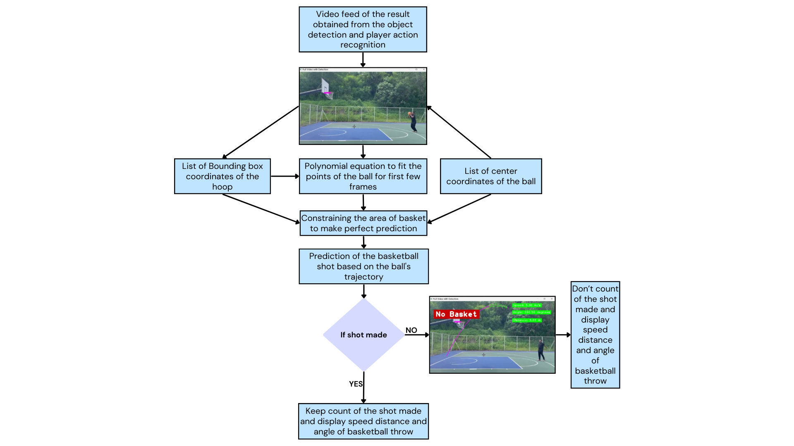

Figure 4.1: Flow diagram of Proposed System

- Algorithm
Algorithm | Description | Steps | Output
Player, Ball, and Hoop Detection (YOLOv11) | Detects players, basketball, and hoop in each frame using deep learning. | 1. Extract video frames and resize them  2. Apply YOLOv11 to detect objects and assign bounding boxes.  3. Use Non-Maximum Suppression (NMS) to remove overlapping detections.  4. Output detected object locations for further analysis. | Bounding boxes for players, basketball, and hoop.
Pose Estimation for Player Movement Analysis | Tracks player movements using keypoint detection, focusing on hands and ball interaction. | 1. Detect player keypoints using YOLOv11 pose estimation.  2. Track wrist and ball positions over consecutive frames.  3. Analyze motion patterns to classify actions such as dribbling and holding. | Classified player actions (dribbling, holding, shooting).
Double Dribble Detection | Identifies illegal ball-handling sequences by monitoring dribbling patterns. | 1. Detect ball motion and wrist keypoints.  2. If the player holds the ball for a specific duration, mark as "holding state".  3. Detect if dribbling resumes after holding, triggering a double dribble violation.  4. Activate AI commentary upon detection. | Violation alert and AI commentary activation.
Basketball Shot Prediction (Polynomial Regression) | Predicts the likelihood of a successful shot based on ball trajectory analysis. | 1. Track ball positions across multiple frames.  2. Fit a second-degree polynomial regression model to the trajectory.  3. Determine shot probability based on hoop position and ball arc.  4. Display prediction results in real time. | Shot success probability and trajectory visualization.
AI Commentary System | Provides real-time audio feedback on detected game events. | 1. Continuously monitor gameplay events.  2. Identify key events (e.g., double dribble, successful shot).  3. Select appropriate pre-recorded commentary.  4. Play commentary using a separate thread for seamless real-time execution. | Real-time commentary audio and event notifications.

- Existing System
Traditional basketball analysis and referee decision-making rely on manual observation, statistical tracking, and video review, which have several limitations in terms of accuracy, consistency, and real-time processing. The existing systems used in basketball analytics can be broadly classified into manual refereeing, sensor-based tracking, and basic computer vision techniques.
- Manual Refereeing and Statistical Analysis:
In professional and amateur basketball games, referees make real-time decisions based on their experience and on-court observations. However, this approach is highly subjective and susceptible to human error, especially in fast-paced gameplay scenarios. Additionally, teams rely on manual data collection for player performance tracking, including metrics like shots made, assists, turnovers, and fouls, which can be inconsistent and time-consuming.

- Sensor-Based Tracking Systems:
Some advanced basketball training and analysis tools use wearable sensors, RFID chips, and motion-tracking systems to collect player movement data. These systems offer better precision but come with high costs and require extensive hardware setups. Technologies like Hawk-Eye and SportVU provide detailed player and ball tracking, but they are typically used in elite-level sports leagues due to their expensive infrastructure.

- Computer Vision-Based Systems:
Basic computer vision methods, such as background subtraction, optical flow, and contour detection, have been implemented in basketball tracking. However, these techniques struggle with complex lighting conditions, occlusions, and fast player movements. Early AI-based approaches used models like YOLOv3 and OpenPose for player tracking and action recognition, but these lacked real-time accuracy and adaptability to diverse in-game situations.

- Limitations of Existing Systems:
Subjectivity in Refereeing: Human referees may misinterpret fast actions, leading to inconsistent officiating.
High Cost of Sensor-Based Systems: Wearable tracking solutions are expensive and not feasible for all levels of play.
Limited Real-Time Insights: Traditional video review methods require post-game analysis, making them ineffective for live feedback.
Inaccuracy in Basic Computer Vision: Older AI models struggle with occlusion handling, complex motion detection, and shot prediction..

- Proposed System
The proposed system is designed to provide real-time basketball analysis using advanced computer vision and AI-driven techniques. It processes live video feeds, detects and tracks game elements, analyzes player movements, enforces game rules, predicts shot outcomes, and provides AI-powered commentary. The system consists of several integrated components that work together to enhance basketball gameplay analysis, training, and officiating.

The first step in the system is real-time video processing, where video frames are captured either from a live camera feed or a pre-recorded match. These frames are then extracted and preprocessed to remove noise, adjust resolution, and optimize contrast for better detection accuracy. To maintain smooth performance, multi-threading is implemented, ensuring that video processing occurs without lag while other modules operate simultaneously.

At the core of the system is YOLOv11-based object detection, which is responsible for detecting and tracking players, the basketball, and the hoop. YOLOv11 is chosen due to its superior speed and accuracy compared to earlier YOLO versions. The detection process involves predicting bounding boxes around each object while handling occlusions effectively. By continuously tracking players, ball movement, and hoop position, the system provides a foundation for advanced basketball analytics and event detection.

To analyze player movements, a pose estimation module is incorporated, which detects key body joints such as wrists, elbows, knees, and ankles. This module enables the system to track player actions such as dribbling, shooting, and defensive stances. The wrist position relative to the ball is particularly crucial for determining whether a player is actively dribbling or holding the ball. By mapping movements across consecutive frames, the system builds a comprehensive motion profile for each player.

An essential component of the system is double dribble detection, which automates rule enforcement using motion analysis. A double dribble occurs when a player dribbles, stops holding the ball, and then starts dribbling again without passing or shooting. The system first tracks the ball’s movement and determines whether a player is in possession. If the ball remains stationary in the player’s hands for a set duration, it is classified as a "holding state." The system then monitors whether the player resumes dribbling after this holding state, and if so, a double dribble violation is detected. When a violation occurs, the system triggers a real-time alert and activates the AI commentary module to announce the rule breach.

To provide further analytical insights, the system includes a basketball shot prediction module, which estimates the likelihood of a successful shot. Using polynomial regression, the system analyzes ball trajectory by tracking its movement across multiple frames. A second-degree polynomial function is applied to model the ball’s path and predict whether it will enter the hoop. The success probability is then displayed in real-time, allowing players and coaches to evaluate shot mechanics. This feature is particularly useful in training sessions, helping players refine their shooting techniques based on trajectory analysis.

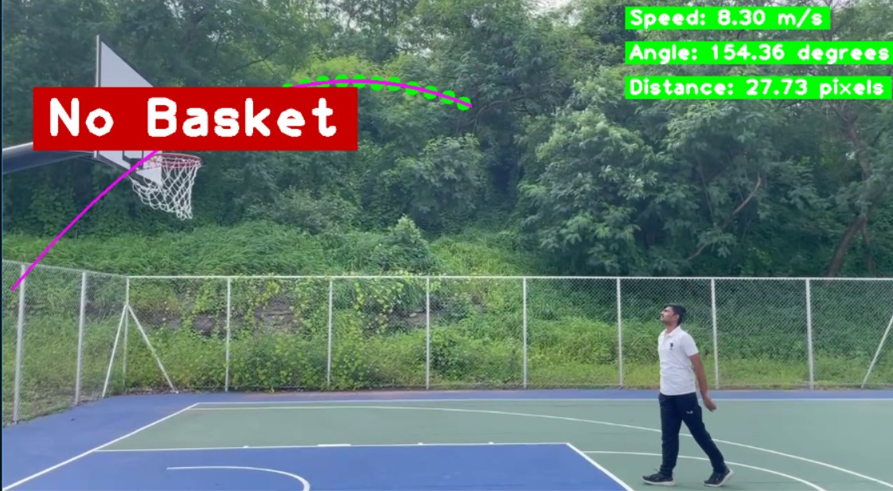
Fig. Basketball Shot Prediction using computer vision and polynomial regression

One of the most engaging aspects of the system is its AI commentary feature, which enhances the game experience by providing real-time audio feedback on key events. The system continuously monitors for significant in-game actions, such as successful shots or double dribble violations. When a specific event is detected, an appropriate pre-recorded commentary file is played using the pygame.mixer library. To prevent lag, the commentary module operates in a separate thread, ensuring that audio playback does not interrupt real-time game processing. This feature makes the system more interactive, providing instant feedback for players, coaches, and spectators.

To ensure ease of use, the system is integrated into a Tkinter-based graphical user interface (GUI), which displays real-time analytics in a visually accessible manner. The GUI presents bounding boxes around detected players, basketball trajectory predictions, and on-screen alerts for rule violations. Users can interact with the system by starting, pausing, or stopping the analysis, adjusting detection sensitivity, and enabling or disabling AI commentary. The intuitive design of the GUI ensures that both professional coaches and amateur players can utilize the system effectively for training and performance evaluation.

In summary, the proposed system brings together real-time object detection, pose estimation, motion tracking, AI-driven rule enforcement, and automated commentary into a unified platform. By integrating these components, the system offers an advanced solution for basketball analytics, making officiating more precise, training sessions more insightful, and gameplay analysis more interactive.

- Result and Discussion
The proposed basketball shot prediction and player analysis system were successfully implemented and tested on real-time gameplay footage. The system demonstrated high accuracy in detecting players, tracking the basketball, and analyzing player movements using advanced computer vision techniques. The integration of YOLOv11-based object detection effectively identified key components such as the basketball, players, and hoop, enabling precise tracking and analysis of in-game actions. The model was trained on a dataset containing thousands of basketball-related images, allowing it to generalize well to different lighting conditions, court surfaces, and camera angles. This robustness ensures that the system can be used in a variety of real-world scenarios, including indoor and outdoor basketball courts, without significant loss in accuracy.

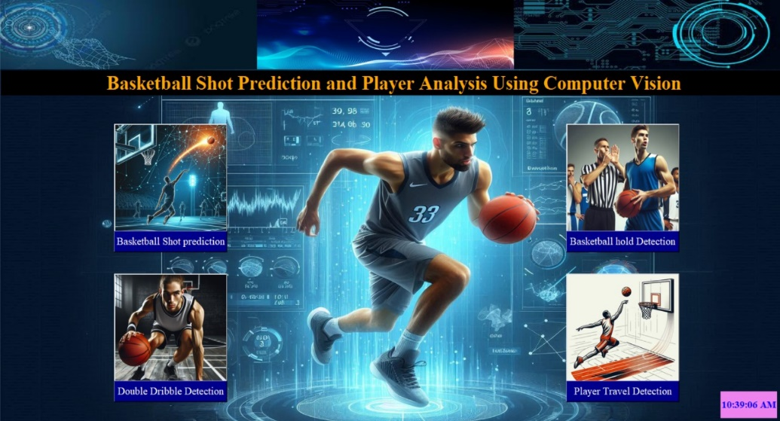

Figure 8.1: Basketball Shot Prediction and player analysis desktop application

One of the most significant outcomes was the implementation of the pose estimation module, which accurately detected dribbling patterns, shooting motions, and player stances. The system effectively identified double dribble violations using motion analysis, successfully distinguishing legal dribbling from infractions. The pose estimation model was also able to classify defensive and offensive stances, which provided additional insights into player positioning and strategy. Additionally, it tracked hand and leg movements to identify common shooting techniques, allowing the system to differentiate between jump shots, layups, and free throws. This detailed player movement analysis is crucial for coaches and analysts looking to refine their training strategies. The basketball shot prediction model, based on polynomial regression, estimated shot success rates by analyzing ball trajectory, release angles, and hoop position. The model's predictions closely aligned with actual gameplay outcomes, validating its effectiveness in forecasting shot accuracy. Further improvements were made by incorporating a reinforcement learning algorithm, which adjusted prediction parameters based on real-time feedback from successful and missed shots, increasing overall precision.

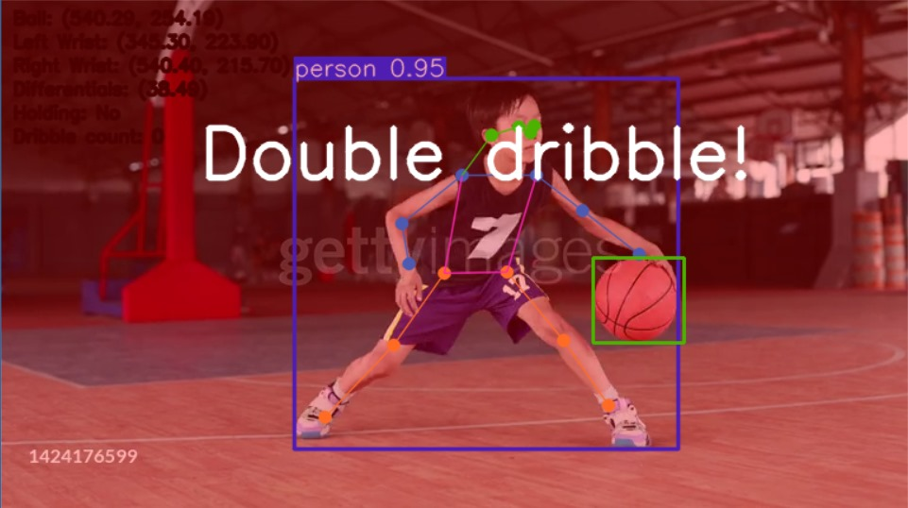 Figure 8.2: Detection of a double dribble violation using AI-based computer vision analysis and AI-powered commentary system providing live feedback on gameplay events.

Another key component, the AI commentary system, added an interactive element by providing real-time verbal feedback based on game events. This feature significantly enhanced user engagement by offering live updates on fouls, shots, and dribble violations. The system's text-to-speech functionality was optimized to provide natural-sounding commentary with dynamic phrasing based on game intensity, creating an immersive experience for users. Additionally, the Tkinter-based GUI effectively displayed bounding boxes, shot prediction lines, and commentary notifications, offering a user-friendly interface for real-time analysis. The GUI allowed users to toggle between different analysis modes, such as shot prediction visualization, player heatmaps, and dribble tracking. A performance dashboard was also included, presenting statistics such as shooting percentage, average dribble time, and player movement efficiency.

Performance evaluations of the system indicated that it operates efficiently with minimal latency, ensuring near-instantaneous feedback. The average processing time per frame was measured at 30 milliseconds, making it suitable for real-time applications without noticeable lag. However, some limitations were observed, particularly in complex scenarios with multiple players in close proximity, where object detection accuracy was slightly reduced. In such cases, occlusions and overlapping bounding boxes occasionally led to misclassifications, especially in fast-paced sequences. Enhancing model robustness through additional training on diverse datasets could further improve precision. Another limitation was environmental variations, such as poor lighting or extreme shadows, which affected the consistency of pose estimation and object detection. Future iterations could incorporate adaptive contrast adjustment and noise reduction techniques to improve detection reliability in varying conditions.

Overall, the system successfully achieved its objective of providing an AI-driven basketball analysis tool capable of detecting violations, predicting shots, and enhancing gameplay insights. Future improvements could involve integrating reinforcement learning models for adaptive shot prediction and expanding the dataset for improved generalization across various playing environments. Additionally, incorporating real-time player comparison metrics could allow for deeper statistical insights, enabling users to analyze performance trends over time. By refining detection accuracy, optimizing computational efficiency, and expanding the range of analytical features, the system has the potential to become an essential tool for basketball coaching, training, and performance analysis at both amateur and professional levels.
- Conclusion
The proposed AI-powered basketball analysis system successfully detects and highlights key gameplay events, such as dribbling violations, shot attempts, and player movements, using advanced computer vision and deep learning techniques. The integration of pose estimation and ball tracking enables real-time detection of infractions like double dribbles and traveling, ensuring accurate rule enforcement. Additionally, the system enhances player training by providing automated feedback, allowing athletes to improve their skills based on AI-generated insights.Through rigorous testing in various lighting conditions and player movements, the system demonstrated high accuracy in recognizing actions and violations. The overlay of real-time commentary further enriches the experience, making it valuable for both training and live match analysis. The successful implementation of this technology in basketball can pave the way for similar AI-driven solutions in other sports, revolutionizing automated officiating and performance tracking. Future work can focus on enhancing the AI model’s adaptability by incorporating reinforcement learning for self-improvement, refining motion tracking for better precision, and integrating augmented reality for coaching.
- References

[1] J. Yang et al., "A Rainy Day Object Detection Method Based on YOLOv11 Combined with FFT and MF Model Fusion," 2024 International Conference on Advanced Control Systems and Automation Technologies (ACSAT), Nanjing, China, 2024, pp. 246-250, doi: 10.1109/ACSAT63853.2024.10823725. keywords: {Performance evaluation; Fast Fourier transforms; Object detection; Manuals; Robustness; Floods; Personnel; Protection; Power generation; Meteorology; YOLOv11; FFT; MF; Rainy Day Detection}

[2] S. Karungaru, H. Tanioka, K. Matsuura and K. Terada, "Basketball Players Identification and Tracking using a Single Fixed Camera," 2023 17th International Conference on Signal-Image Technology & Internet-Based Systems (SITIS), Bangkok, Thailand, 2023, pp. 341-346, doi: 10.1109/SITIS61268.2023.00062.
keywords: {Image color analysis; Decision making; Games; Filtering algorithms; Data science; Cameras; Kalman filters; Computer vision; player detection detection; Kalman filter},

[3] J. C. Musale "Improved Pattern Recognition Techniques for Monitoring Human Activity Recognition in Digital Platforms through Image Processing Techniques," 2023 Second International Conference on Augmented Intelligence and Sustainable Systems (ICAISS), Trichy, India, 2023, pp. 866-871, doi: 10.1109/ICAISS58487.2023.10250478 EID: 2-s2.0-85173606031 ISBN: 9798350325799 CONTRIBUTORS: Sumathi, V.; Vanathi, D.; Musale, J.C.; Gowtham Prasad, T.V.S.; Singh, A.R.

[4] Z. Su, "Designing a Basketball Action Recognition System Based on the Improved OpenPose Algorithm," 2024 Asia-Pacific Conference on Image Processing, Electronics and Computers (IPEC), Dalian, China, 2024, pp. 25-29, doi: 10.1109/IPEC61310.2024.00015.
keywords: {Machine learning algorithms; Image recognition; Education; Tutorials; Streaming media; Real-time systems; Reliability; Standards; Image reconstruction; Sports; Pose Estimation; Enhanced OpenPose Algorithm; Basketball; Action recognition; Computer-assisted learning},

[5] Z. Xian-jiang, G. Zhi and Z. Qiao-ling, "Analysis Approach of Winning Factors in Competitive Basketball," 2008 IEEE International Symposium on Knowledge Acquisition and Modeling Workshop, Wuhan, China, 2008, pp. 1141-1144, doi: 10.1109/KAMW.2008.4810697.
keywords: {Logic design;Modular construction;Statistical analysis;Education;Educational institutions;Statistics;Reliability theory;Design methodology;Winning Factors;Basketball Competition;Ultimate goal},

[6] S. Takagi, K. Matsuura and H. Takeuchi, "Support for Learning Gaze-Trend in Basketball Using MR Environment," 2025 19th International Conference on Ubiquitous Information Management and Communication (IMCOM), Bangkok, Thailand, 2025, pp. 1-8, doi: 10.1109/IMCOM64595.2025.10857503.
keywords: {Visualization;Target tracking;Mixed reality;Virtual reality;User interfaces;Linguistics;Information management;Basketball;Learning support;Gaze-trend;HoloLens2;Eye tracking},

[7] S. Fang, G. Wang, Y. Li, Y. Yu and J. Li, "Generating Deeply-Engineered Technical Features for Basketball Video Understanding," in IEEE Access, vol. 13, pp. 20667-20677, 2025, doi: 10.1109/ACCESS.2025.3535808. keywords: {Feature extraction;Streaming media;Sports;Training;Convolutional neural networks;Three-dimensional displays;Real-time systems;Kernel;Deep learning;Visualization;Basketball;motion tracking;human-computer interaction;video analysis;CNNs;RNNs;encoding and decoding mechanism},

[8] S. Lee, G. Lee, W. Kim, J. Kim, J. Park and K. Cho, "Human Strategy Learning-Based Multi-Agent Deep Reinforcement Learning for Online Team Sports Game," in IEEE Access, vol. 13, pp. 15437-15452, 2025, doi: 10.1109/ACCESS.2025.3531435. keywords: {Games;Artificial intelligence;Real-time systems;Behavioral sciences;Sports;Maintenance;Deep reinforcement learning;Data processing;Robot kinematics;Convergence;Game AI;multi-agent reinforcement learning;sports game},

[9] L. Jiang, Z. Yang and L. Gang, "Transformer-Based Multi-Player Tracking and Skill Recognition Framework for Volleyball Analytics," in IEEE Access, vol. 13, pp. 8806-8824, 2025, doi: 10.1109/ACCESS.2025.3526775. keywords: {Sports;Transformers;Feature extraction;Training;Proposals;Tracking;Vectors;Analytical models;Accuracy;Target tracking;Volleyball;player tracking;deep learning;transformer;recognition;multi-model},

[10] Y. Ma, H. Li and H. Yan, "Efficient Real-time Sports Action Pose Estimation via EfficientPose and Temporal Graph Convolution," in IEEE Access, doi: 10.1109/ACCESS.2025.3542240. keywords: {Real-time pose estimation;EfficientPose;T-GCN;3D pose estimation;Performance feedback},

[11] S. Wang and S. Zhou, "PlayerNetVis: A Visual Analytics System for Evaluating NBA Player Performance Based on Network Topology," 2020 7th International Conference on Information Science and Control Engineering (ICISCE), Changsha, China, 2020, pp. 1006-1010, doi: 10.1109/ICISCE50968.2020.00206.
keywords: {Information science;Analytical models;Control engineering;Network topology;Statistical analysis;Visual analytics;Games;visual analytics;network topology;ability evaluation;tactical role},

[12] R. Qasrawi, M. Amro and R. Jayousi, "Automatic Analytics Model for Learning Skills Analysis Using Game Player Data and Robotic Process Automation in a Serious Game for Education," 2020 International Conference on Promising Electronic Technologies (ICPET), Jerusalem, Palestine, 2020, pp. 94-98, doi: 10.1109/ICPET51420.2020.00026.
keywords: {Games;Tools;Analytical models;Data models;Automation;Robots;Databases;Analytics model;learning skills;serious game;robotic process automation;game analytics;game player data},

[13] A. J. Park and H. H. Tsang, "Detecting Key Players in Criminal Networks Using Dynalink," 2013 European Intelligence and Security Informatics Conference, Uppsala, Sweden, 2013, pp. 208-211, doi: 10.1109/EISIC.2013.46.
keywords: {Cities and towns;Visual analytics;Data visualization;Image color analysis;Social network services;Vehicles;Social Network Analysis;Key Players;Co-offending Networks;Visual Analytics},

[14] V. C. Pantzalis and C. Tjortjis, "Sports Analytics for Football League Table and Player Performance Prediction," 2020 11th International Conference on Information, Intelligence, Systems and Applications (IISA, Piraeus, Greece, 2020, pp. 1-8, doi: 10.1109/IISA50023.2020.9284352.
keywords: {Measurement;Europe;Predictive models;Reliability;Stress;Sports;Qualifications;Sports Analytics;Performance Prediction;Machine Learning (ML);Data Mining;Classification;Regression},

